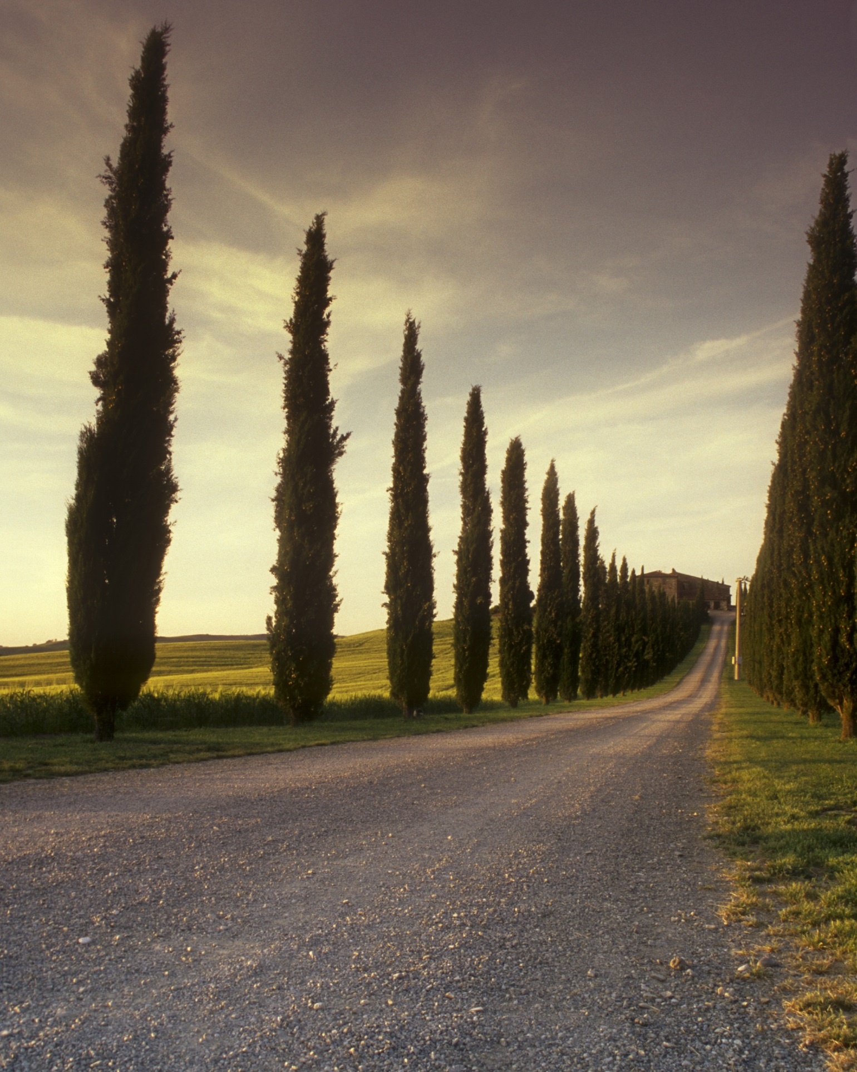  A 2D Ruguelike Game in Pixel Style | 4th Final year project  Shunyi Xu (20100201)

Table of Contents
1. Table of Contents 2
2. Game Overview 4
2.1. Game Concept 4
2.2. Genre 4
2.3. Target Audience 4
2.4. Game Flow Summary 5
2.5. Look and Feel 5
2.6. Project Scope 5
3. Gameplay and Mechanics 8
3.1. Gameplay 8
3.2. Mechanics 9
3.3. Screen Flow 11
4. Story,Setting and Character 12
4.1. Story and Game Progression 12
4.2. Game World 13
5. Interface 13
5.1. Visual System 13
5.2. Control System 14
5.3. Audio 14
5.4. Music 14
5.5. Sound Effects 14
5.6. Help System 15
6. Artificial Intelligence 15
7. Technical 18
7.1. Target Hardware 18
7.2. Development hardware and software 18
7.3. Game Engine 18
7.4. Scripting Language 18
8. Game Art 19
8.1. Concept Art Characters 19
8.2. Environments 19
8.3. Equipment 19
9. Project Management 19
9.1. Project Methodology: 19
9.2. Detailed Schedule 20
9.3. Version control. 20
9.4. Risk Analysis 20
9.5. Test Plan 21
10. Appendices 21
10.1. Credits: 21
10.2. References 21
10.3. Project logs. 22

Game Overview

Game Concept
The whole game is a 2D roguelike game in pixel style.Players can move through adjacent grids on a map consisting of 30 grids, 5 rows and 6 columns.Various events are randomly generated on the map, including fighting enemies, passing tests, and more. There are only two unique events among them, the Goddess Statue and the Demon King. The Goddess is the birth point of the character, it is fixed in the grid in the upper left corner of the map, and the Demon is the boss of the game, it appears randomly in the rest of the map. Only defeating him can the player win the game.
Player will obtain equipment and props by going through different events, and be able to upgrade and improve attributes and acquire new skills by gaining experience.

Genre
This game is a 2D roguelike game in pixel style, and the main picture materials are all in pixel style. At the same time, the roguelike type is adopted in the game mechanism, and the random equipment and props drop make the game richer.

Target Audience
Roguelike is a general term for a game that follows the gameplay of the 1980s game Rogue, developed by two software engineers, Michael Toy and Glenn Wichman, on the UNIX system and running on the mainframe. The original purpose of the game is to reproduce the "DND" game experience on the computer, and strictly follow the "DND" game rules of the single turn role-playing game.
The features with high frequency of Roguelike include:
1. Generate randomness. Every new start will randomly generate game scenes, enemies, treasures and other different things. And every adventure of the player will be unique and cannot be copied. This greatly improves the replayability of the game.
2. Non-linear. Rigorous yet flexible game rules give Roguelike a very high degree of freedom. In the game, players can use their imagination to solve problems encountered in the game through different methods and combinations of props.
3. System complexity. Roguelike games may include an incalculable number of elements in one game, and in some games may include hundreds of causes of death, thousands of creatures, and tens of thousands of items.
Roguelike games have recently returned to the game charts, such as Slay the spire, Dead Cells.
When pixel art just started, it was more about practicality than artistry. It is an art form that uses basic graphics such as points, lines, and squares to carry or transmit visual information.
Dragon Quest is Japan's first game and the original catalyst of the Japanese video game industry. It is an electronic role-playing game series released by Japan's Enix on May 27, 1986. It is one of the best-selling longevity game series in game history. It is known as "National " in Japan. With its influence, has been synonymous with Japanese games for a long time in the world. Even though the level of technology has greatly improved compared to that era, many -specific elements have been handed down from then to modern times. It also ties together rpg elements and pixel art.
What I hope to attract are some old players and new players who focus on gameplay rather than graphics. The entire game process is very short, which is also in line with the tendency of fragmented games. You can play a game in your free time.

Game Flow Summary
Throughout the game process, the player mainly controls the movement of the character through the mouse from a bird's-eye view and clicks the button icon to perform UI interactions, such as opening the backpack, using props, and fighting.

Look and Feel
Most of the graphic elements are in pixel style.

Project Scope

Numbers of events
There are a total of 8 events, which can be divided into 4 categories.
Categories of events：
- Rest
- Battle
- Test
- Treasure Chest

Events:
- Goddess statue
This is the rest event and the unique event. It is the birth point of the character and the starting point of the game. The position is fixed at the upper left corner of the map. After that, every time the character walks to the position of the goddess statue, he will get a rest and restore all HP and MP.
- Grave:
This is a type of battle. The enemy will be skeleton. In the battle, the skeleton will have a certain ability to avoid damage, which means that any damage received by the skeleton will be reduced by a fixed value.
- Pool:
This is a type of battle. The enemy will be murloc. In the battle, the location will be in the pool, so the character will be greatly disturbed by the environment, that is, the environment debuff called the river will be applied, so the character's There will be a significant drop in hit probability.
- Coffin:
This is a type of battle. The enemy will be vampire. When the vampire attacks the character and causes damage, the vampire will recover a certain amount of health points.
- Demon King:
This is one and only event of the match. The Demon is the final boss of the game, defeating him can end the game and win.
- Ruins:
This is a kind of test. Players need to go through the determination of the strength attribute. Only when it is higher than or equal to a certain value can they move the stone and get rewards. Otherwise, they will be punished, such as injury, or permanent attribute reduction.
- Bridge:
This is a kind of test, similar to the ruins, but the difference is that the player needs to pass the determination of the agility attribute
- Treasure Chest:
This is treasure chest event. When players enter this event, they will randomly get a piece of props or equipment.

Numbers of Attribute

Basic attributes
HP(Health Points)
MP(Mana Points)
EXP(Experience Points):EXP represents the experience and ability improvement that the character has gained in the adventure.
Str(Strength):Movement and basic physical strength.
Dex(Dexterity):Physical flexibility, reflexes, balance and stability.
Int(Intelligence):Mental acuity, recall of information, analytical skills.

Derived Attribute
AC(Armor Class):Character's AC represents its protection against ability to hurt. Armor worn and shields held both will contribute to AC.
Att(Attack):Each weapon held by the character is calculated separately when using it to make an attack, and when using the modifier applied when it hits to deal damage.
The formula for calculating the adjusted value is (Attribute - 10)/2.

2.7.1. Numbers of Level
There are 2 unique events, and the remaining 28 events have an 80% probability of generating an event. Except for the treasure chest, all remaining events will provide experience points once they are successfully passed, and the probability of generating treasure chests and other events is the same. Therefore, calculated according to the probability, there will be about 18 events that can provide experience points.
In order to cope with the 5 levels of difficulty, I hope that the protagonist also has 5 levels to upgrade.
Characters start from level 1 to level 5, and the experience points required for each level-up are 100, 200, 400 and 800.
Difficulty starts from level 0 to level 5, and the experience points that can be obtained for each event are 30, 50, 70, 90 and 110 respectively.

Gameplay and Mechanics

Gameplay

Mission/Challenge Structure
All random events are generated by the class GenerateEvent. Edit the UI component Button in Unity and name it Event as Prefab, to which add Box Collider 2D and create variants by setting different Sprites. Create an empty container and add Grid layout Group to it. The code will generate 30 Events. Set the container as its parent element and add tags through the for loop.
Create an array of events to store events. The goddess statue is stored in events[0]. A random number is generated by System.Random, and the event of the Demon king is randomly stored between events[1] and events[29]. There is a 20% probability that no event will be generated, and the remaining 80% probability determines which type of event is generated.
Through these events, characters can obtain random equipment, props and experience points to upgrade and obtain attribute improvements.
Every event can be regarded as a challenge. The test can fail, but if it fails in the battle and the character's HP returns to 0, the game will end up in failure.

Objective
The goal of the game is to finally reach the location of the Demon king and defeat him to win the final victory.
The difficulty of the game will increase with the number of steps, which will increase every 4 steps, up to 5 times. Specifically, the attributes of the monsters will increase, but the experience points will also increase and the dropped objects will be better.

Play Flow
It's a very quick process when there's action. Click the adjacent grid on the map, the program will immediately determine the direction and play the action animation. When the character stops, if there is an event in the area, a dialog box will pop up immediately.
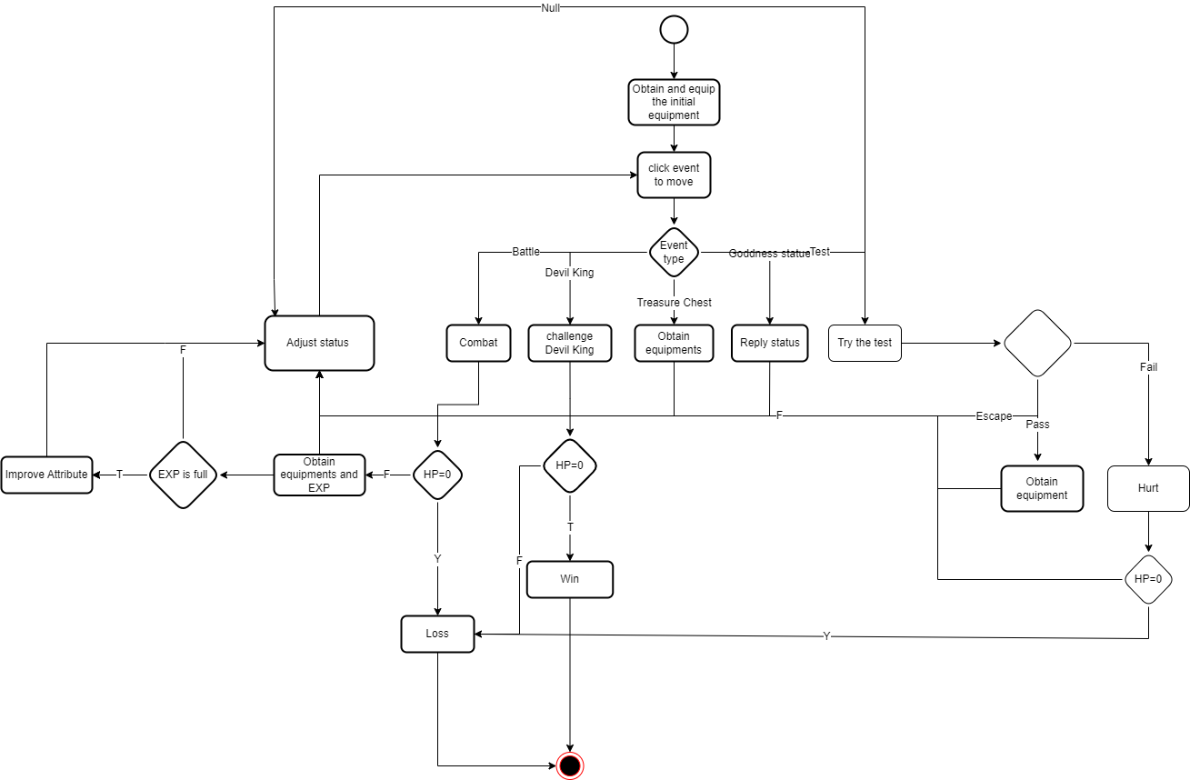
Fig3.1.3.1. Flow Diagram

Mechanics

Physics
Unity2D and 3D are actually a change in perspective. All objects have 3D coordinate information. Every time player click, a ray will be generated through Camera.main.ScreenPointToRay(Input.mousePosition), and it will be projected from the screen to the Prefab with Box collider and tag added before to get the corresponding components.

Movement
In Unity, Sprite is a control used to draw an atlas, which can capture a part of a large image. I import the character walking picture in the format of png, which was cut with the cell size through the editor. Use 2D simple directional blend tree to make animations about walking in four directions, and finally add parameters xDir and yDir, which are respectively the abscissa and ordinate of the character's moving direction vector, to determine the switching of the walking direction animation.
After clicking, the program will get the coordinates of the component obtained through ray detection, which is compared with the those of the character to calculate the moving direction and target. Vector2.MoveTowards(Vector2 current, Vector2 target, float DistanceDelta) implements this function.
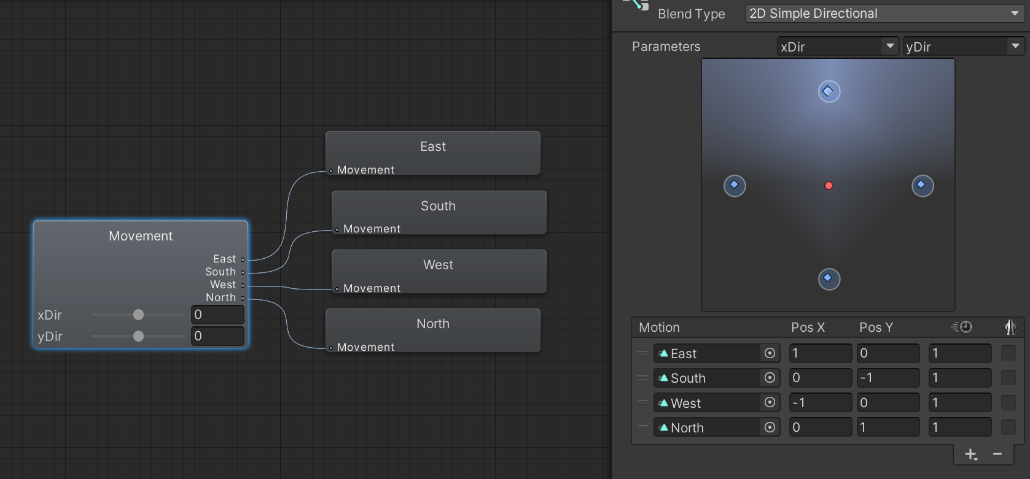
Fig3.2.2.1.2D Simple Directional Blend Tree

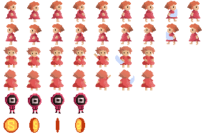
Fig3.2.2.2.2D Chararcter Walking Chart

Objects
All items are created through the class Item(), and finally set the properties of the variables.
There is no relevant picking up animation in the game. Instead, after each event, there will be a tip prompting the player to confirm to accept the item or discard it. If the player confirms to accept the item and the number of props does not exceed the limit of the backpack column, the item will be added directly to the backpack.

Actions

Switches and Buttons
Players can open the backpack and character attribute interface by clicking the backpack button at the UI level.

Picking Up, Carrying and Dropping
Clicking on the backpack grid with items will pop up a detailed introduction, and player can choose to use or discard items.

Dialogue
Before entering the event, a dialog box and corresponding text will be generated, and the player can get a last chance to make the decision.

Combat
Battle will be carried out in the form of a turn system, simply referring to the rules of the DnD board game. A successful attack will be divided into two parts. The first step is to conduct a hit judgment, generate a random number from 1 to 20, add the corresponding attribute adjustment value, if it is not less than the opponent's AC, enter the process of determining the damage, Generate random numbers and adjustments corresponding to weapon attack values.

Screen Flow

Screen Descriptions

3.3.1.1.Main Screen
The map interface will be the main interface of the player, and the main action area of the character is in the area composed of the 5X6 grid in the center.

3.3.2.2.Head Logo
The Head Logo is in the upper left corner of the UI hierarchy, showing the character's avatar and simple information of attributes. Set the image type to Filled and Horizontal, the attribute bar will dynamically display the ratio of the current HP, MP, EXP and the upper limit.

3.3.2.3.Backpack Screen
Click the backpack button on the left, and the backpack interface will appear. It is also implemented through Grid Layout Group, and repeatedly added as the Prefab of Slot.
Click each backpack grid, a detailed introduction will pop up, as well as buttons for using and discarding.
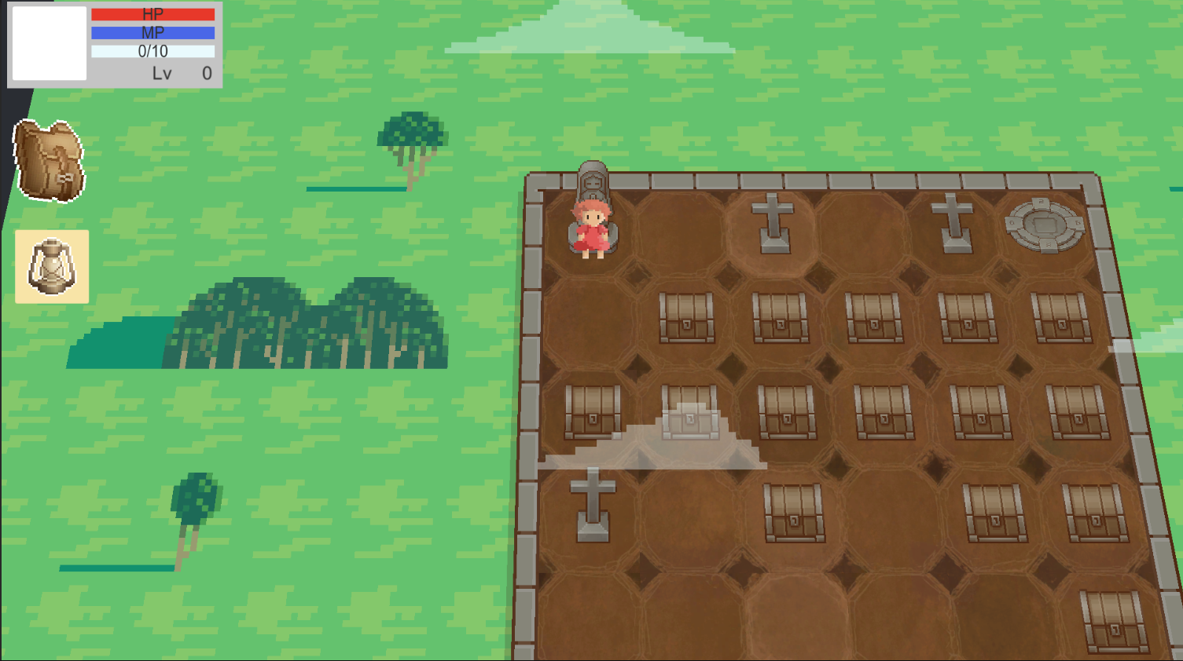
Fig3.2.3.3.1.Screen

Story,Setting
The background story is a western fantasy world, the Demon king is about to wake up from the seal, so the goddess chose the player. Player needs to save the world by defeating the Demon king.
But now, with the recovery of the Demon King, many monsters following the Demon King have awakened first, occupying a large area of the kingdom.

Game World

General Description
It can be seen as a kingdom surrounded by grasslands and forests. The kingdom is surrounded by walls and borders. Each grid represents a large area in the kingdom. The different icons on top are specific to the current region, maybe there are skeletons coming back from the cemetery, there might be vampires waking up from coffins, or there might be lost treasure in the area.
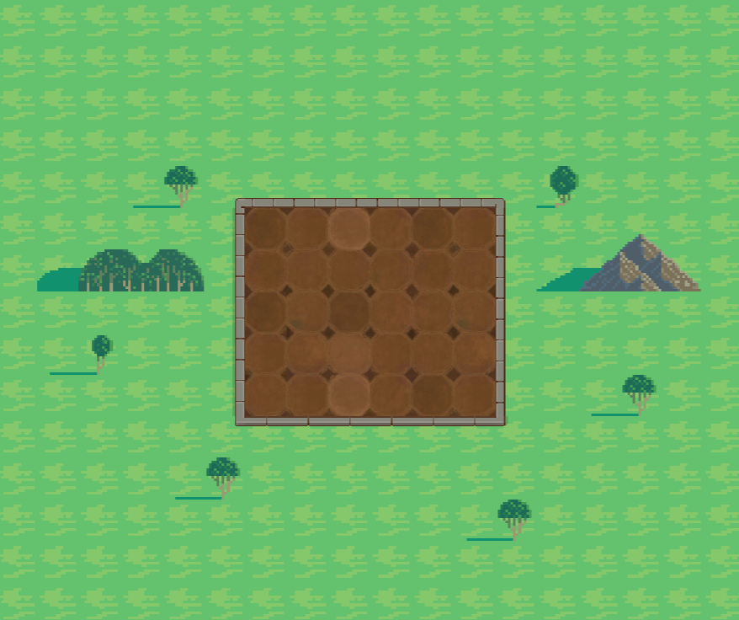
Fig4.1.1.1.Game World and Map

Interface

Visual System

HUD
Main Screen
The map interface will be the main interface of the player, and the main action area of the character is in the area composed of the 5X6 grid in the center.
Head Logo
The Head Logo is in the upper left corner of the UI hierarchy, showing the character's avatar. Set the image type to Filled and Horizontal, and the attribute bar will dynamically display the ratio of the current HP, MP, EXP and the upper limit.
Backpack Screen
Click the backpack button on the left, and the backpack interface will appear. It is also through the Grid Layout Group, and repeatedly added as the Slot of the Prefab. Click on each backpack grid, and a detailed introduction will pop up, as well as buttons for use and discard.

Camera
During the entire game, use the player as the parent element of the camera, and the camera will move with the movement of the character. Set the camera's y coordinate to a complex number, so that the player's perspective becomes a bird's-eye view.
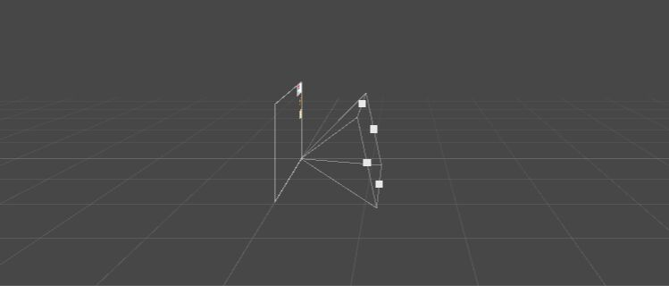
Fig5.1.2.1. Player's perspective

Control System
All controls are performed with mouse clicks, including moving, opening backpacks, using or discarding equipment, and selecting abilities.
The click event at the UI level is realized by adding onClick.AddListener(delegate (){}) to the UI component Button.

Audio
I will download audio from free internet libraries.

Music
The background music will use the pure music from the classic Japanese game "SoranoKiseki".

Sound Effects
The sound effects used are provided by Unity-related paid courses purchased online, including movement, attack, injury, etc.

Help System
The game provides a short text notification in the upper right corner if the player has progressed to a particular part of the game. At the same time, some icons, such as the status during the battle, will also be introduced in the upper right corner.
This area will be a translucent dark color, and the font will be white, which will make the prompt more conspicuous, and also avoid the phenomenon that some handwriting is difficult to read because of the similar color when the character is moving due to the different colors of the map.

Artificial Intelligence

7.1. Enemy AI
Each enemy will be a class with a common parent class Enemy. Attacks are written as functions that are called every turn.

7.1.1. Skeletons
Introduce
Skeletons are invoked by dark magic activations. They are summoned by spellcasters from stone tombs or ancient battlefields, or awakened in lands of death and destruction, disturbed by necromantic energies, or activated by corrupt evil.
Attributes
AC: 13
HP: 13 + 4/level
Str: 10+2/level
DC: 2
Action
Shortsword
The skeleton has only one attack method, he will constantly chop with a short sword.

7.1.2. Kraken
Introduce
Sea monsters once populated the shores and islands of the surface world. But humans and other surface races drove them to the underground world, and now the sea monsters responded to the call of the devil to take revenge.
Attributes
AC: 13
HP: 18 + 8/level
Str: 11+1/level
Cction
Spear
Net:Target is tethered, and the target's AC receives a temporary decrease.
Sea monsters will use nets first, then attack with spears.

7.1.3. Vampires
introduce
Vampires awakened from the endless night thirst for their lost life, and fill it with the blood of the living.
Attributes
AC: 10 + Dexterity modifier
HP: 13 + 5/level
Dex: 10+2/level
action
Bite: The vampire will recover life equal to the blood sucking damage.
Children of the Night: The vampire uses magic to summon a group of bats to attack. After 4 rounds, it will deal damage to the enemy and recover the life of the damage. It can only be used once.
Vampires will give priority to using Children of the Night, and then keep biting.

7.1.4. Demon King
Introduce
People were deeply shocked by his ruthlessness and evil depravity. He decided that he should become the king who ruled the world. He summoned monsters to serve his ambition.
Attributes
AC:15+1/level
HP: 14+6/level
Str:15+1/level
Int: 15+1/level
Action:
Fiendish Blessing: AC temporarily increased
Spear
Fire Ray
Fire Aura: passive skill, the enemy will be burned every round
The demon king will actively release the demon blessing, and then alternately use the spear and fire ray

Technical

Target Hardware
Finally, the game will be packaged and exported so that it can run on both the PC and Android phones.

Development hardware and software

Hardware
Processor：12th Gen Intel(P) Core(TM) i7-12700H 2.30 GHz
Installed RAM: 16.0GB(15.7 usable)
System type: 64-bit operating system,x64-based processor

Software
Unity 2021.3.15f1
Visual Studio with workload - Game development with unity

Game Engine
Unity2021.3.15f1 is the latest official version when I started developing the prototype. Compared with the previous test version, it has undergone more tests and is more stable.

Scripting Language
C# is the language used to program games in Unity. Earlier versions of Unity accept more kinds of programming languages, such as BOO, Unity Script, etc. But the latest version of unity accepts C#.

Game Art

Characters
DUDUGO: https://www.bilibili.com/video/BV1BG411M7wS/?spm_id_from=333.788&vd_source=270a6501484d556a97e3f837a9347d20

Environments
Pbr Stylized Textures: https://assetstore.unity.com/packages/2d/textures-materials/building/pbr-stylized-textures-214513
Free Pixel Art Overworld Tileset: https://assetstore.unity.com/packages/2d/environments/free-pixel-art-overworld-tileset-232672
Free 2D Cartoon Parallax Background: https://assetstore.unity.com/packages/2d/environments/free-2d-cartoon-parallax-background-205812
Pixel Art Top Down - Basic: https://assetstore.unity.com/packages/2d/environments/pixel-art-top-down-basic-187605

Equipment
Pixel Art Icon Pack - : https://assetstore.unity.com/packages/2d/gui/icons/pixel-art-icon-pack--158343

Project Management

Project Methodology:
The project will use agile development methodology, which are useful as an iterative approach to software development projects, ensuring that feedback can be acted on quickly to make responsive changes.
Compared to the waterfall model, agile development divides the development process into short iterative increments. At the end of each iteration, a final usable product is produced. If the requirements change, the method can be developed in the next iteration cycle.
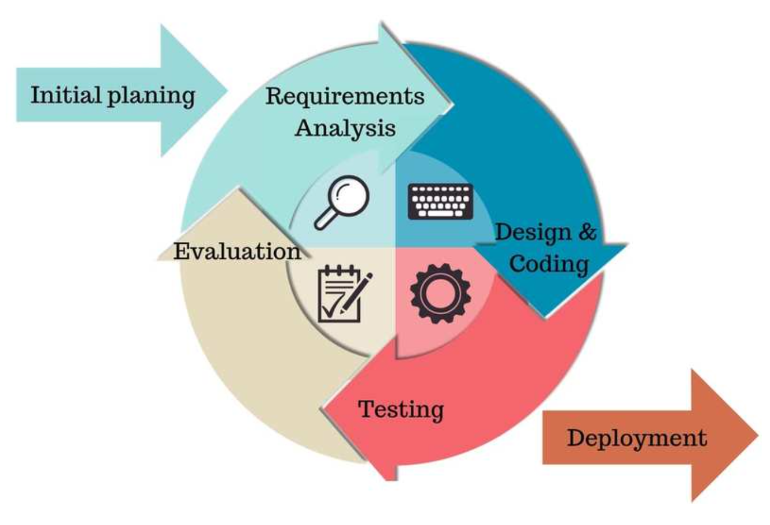
Fig9.1.1. Agile Development Methodology

Detailed Schedule
I divided the entire game into several major parts: map, walking, UI, backpack, equipment, battle, data, sound effects, and animation, among which battle is the most complicated.
I have completed the prototype in the first semester, but the battle, data and some non-functional requirements are still lacking.
In the next semester, I will devote at least 10 hours a week to perfecting this project.

Version control.
Github is a hosting platform for open source and proprietary software projects. As an open source code repository and version control system, Github has more than 9 million developer users. As more and more applications move to the cloud, Github has become the go-to method for managing software development and discovering existing code. So I'm going to use Github to keep pushing the code.
But once the project exceeds 100MB, Github will refuse to upload. So I uploaded only the part where the C# key code is designed, not the whole project.
https://github.com/skateboard-hub/2D-roguelike-game.git

Risk Analysis
(1) Data security
I will use functions to store and call data to keep important parameters of the game safe.
(2) Part of the missing item
I will use github to push the code, after each completion of the corresponding functions and requirements

Test Plan
I will package the project, then send it to my friends or upload it to Android platform for testing, and collect opinions for repeated testing and modification. I will also conduct black-box testing and boundary testing of the software's functions according to the functions of my own design to ensure that each requirement is fulfilled.
Among them, the improvement of the data and difficulty of the enemy will be tested in detail to improve the combat system.

Appendices

Credits:

Images
Most image assets will be imported from the Asset Store and downloaded into Unity. The remaining parts will be downloaded and used from the Internet after confirming that there are no copyright issues.
The overall style is pixelated.

Animations
The animations of this game are all made by me based on the animation editor and sprites in unity, switching under certain parameter conditions, such as movement and attack.

References
The whole process of getting started with the basics of Unity independent game development (2D)：
https://www.bilibili.com/video/BV1BG411M7wS/?spm_id_from=333.880.my_history.page.click&vd_source=270a6501484d556a97e3f837a9347d20
Ray detection, where to move the mouse：
https://www.bilibili.com/video/BV1154y1Q7Zw/?spm_id_from=333.880.my_history.page.click
Make a turn-based battle system for Pokémon-like games:
https://space.bilibili.com/180908/channel/collectiondetail?sid=676527

Project logs.
Youtube:
https://youtu.be/I_Hap1-pUrg

